**User Manual**

Table of Contents

1. Accessing the Sales and Inventory System…………………..……………………….3

2. Login into the system……………………………………………………………………..3

3. Dashboard…………………………………………………..……………...……………..4

4. Add New Employee………………………………………………………...…………..5-6

5. List and View Employee………………………………………………………….…….7-8

6. Update Employee Info……………………………………………………………………9

7. Search Employee………………………………………………………………………..10

8. Add Product………………………………………………………………….……….11-12

9. List Product……………………………………………………………………..…….13-14

10. Add New Stocks………………………………………………………………..……15-16

11. Update Stocks…………………………………………………………………..… 17-18

12. Record Sales…………………………………………………………………….….19-20

13. Show Sales……………………………………………………………………….….21-25

14. Drop down menu…………………………………………………………………..……26

1. **Accessing the Sales and Inventory System.**

Open up the folder “Sales and Inventory System” provided.

You will have to launch the executable file “LAUNCHER.exe” by double click the file.

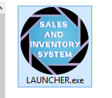

After that, a window will pop up and the system will be up and running.

1. **Login into the system**

Upon launching the system, you will be greets with login page.

Simple insert the user credentials which is Employee ID and Password into the boxes provided and click the blue **LOGIN** button

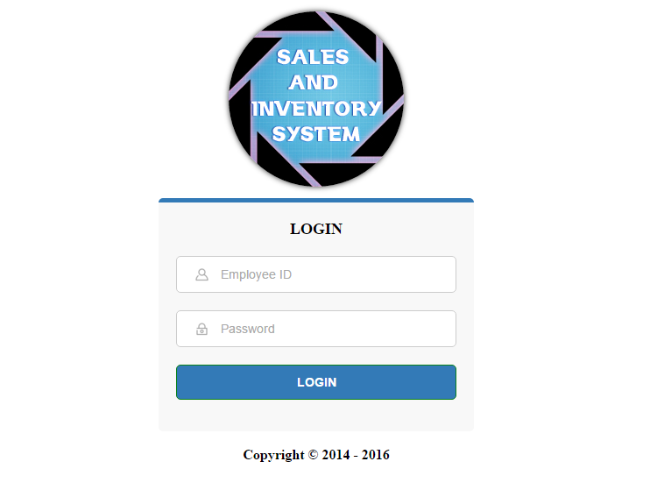

1. **Dashboard**

After successful login, you will see the system’s dashboard.

On the dashboard, you can see information such as the Employee’s ID, Access Level, Notification Panel and Sticky Notes.

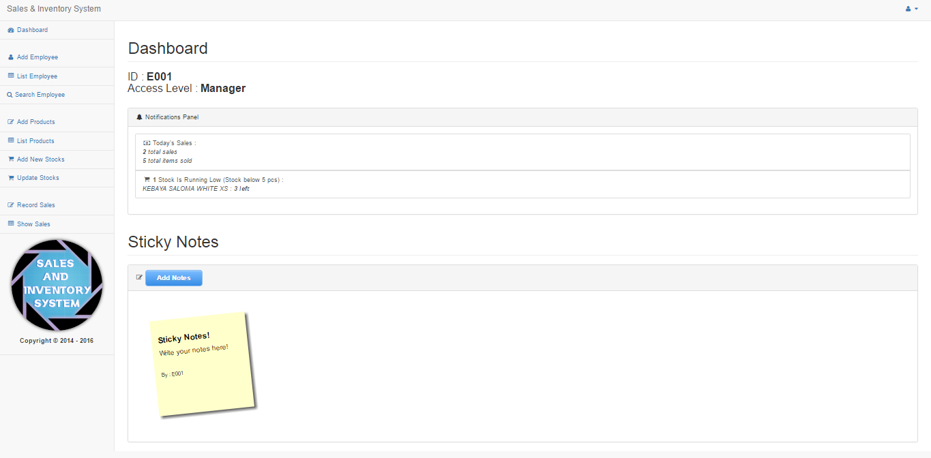

On the left side of the system, you will see the sidebar containing the navigation menus.

1. **Add New Employee**

You have to click on the “Add Employee” menu on the side bar.

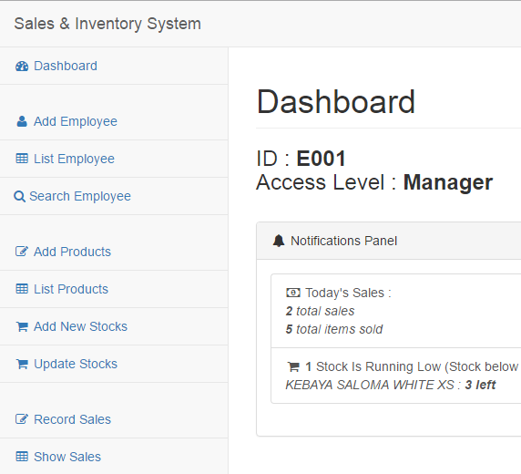

Enter information in each fields.

Note :

* ID must be start with “E”. as example, “E001”.
* Identification Card must be entered with no dash “-“.
* Password for “employee level” must be the same as their ID.
* All fields in capital letters except for Password.

Click “SUBMIT” button to add new employee.

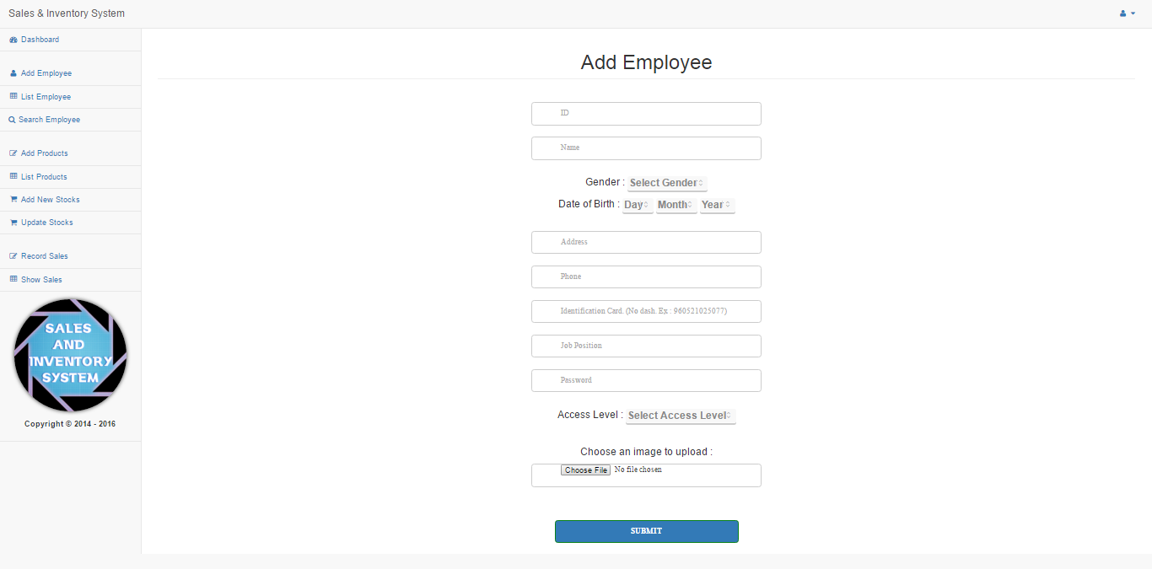

You will see a pop up with message “Success! Data Inserted.” Indicating that the data has been successful submitted.

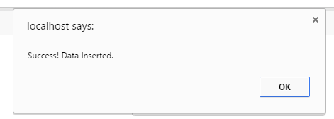

1. **List and View Employee**

You have to click on “List Employee” menu on the sidebar.



After that you will see the list of Employee available.

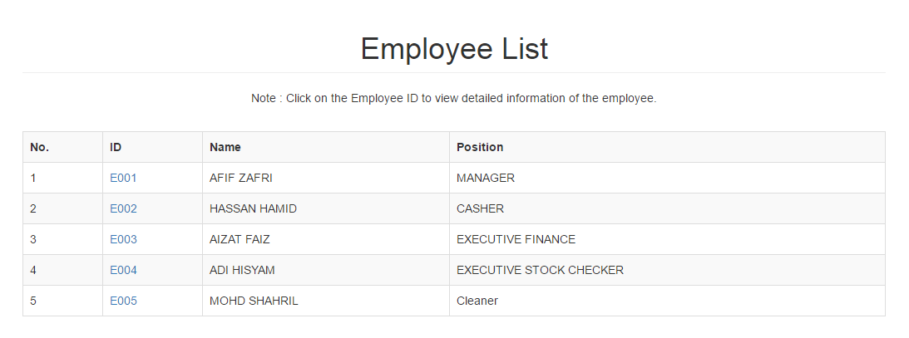

To see the employee profile with full details, click on the Employee ID.

This page will show all the employee details.

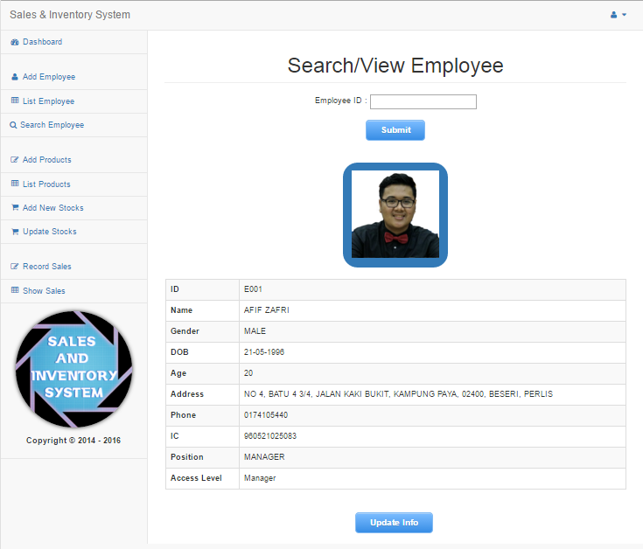

1. **Update Employee Info**

To update employee info, you have to click on “Update Info” button inside the employee profile page.

After that, you will see an update page.

Change the information you want to change and press “UPDATE”.

You can also upload a new photo.

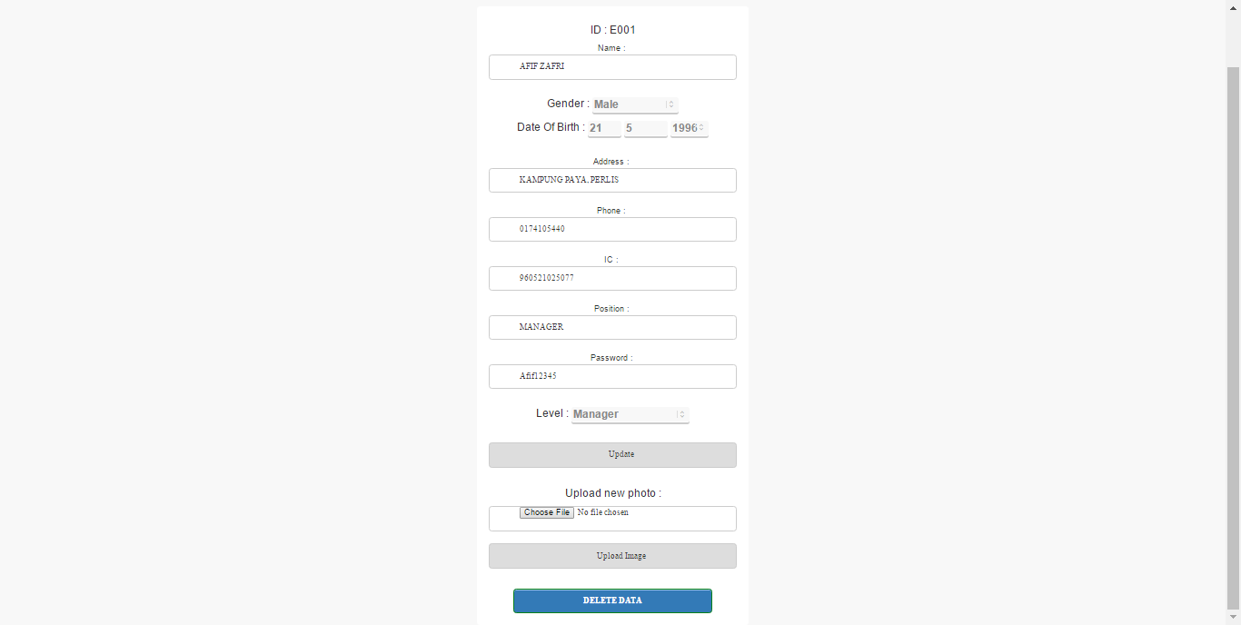

If you want to Delete the Employee Data, you can just press “Delete Data” button.

1. **Search Employee**

You have to click on “Search Employee” menu on the sidebar.



After that you will see the input box and button for searching.

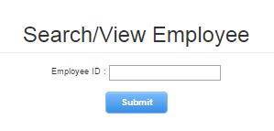

Enter the Employee ID and press “Submit” button.

After submit, you will see the employee profile if the data exist, otherwise, you will see the text “No data available”.

1. **Add Product**

You have to click on “Add Product” menu on the sidebar.



After that you will see Add Product Form.

Enter all required fields.

Note:

* Size, Colors, Sleeve and Flowers/Embroidery MUST be separated by comma if there's more than one option.
* Sleeve and Flowers/Embroidery are OPTIONAL. Leave BLANK if there is no option

Click “Submit” button to save the data.

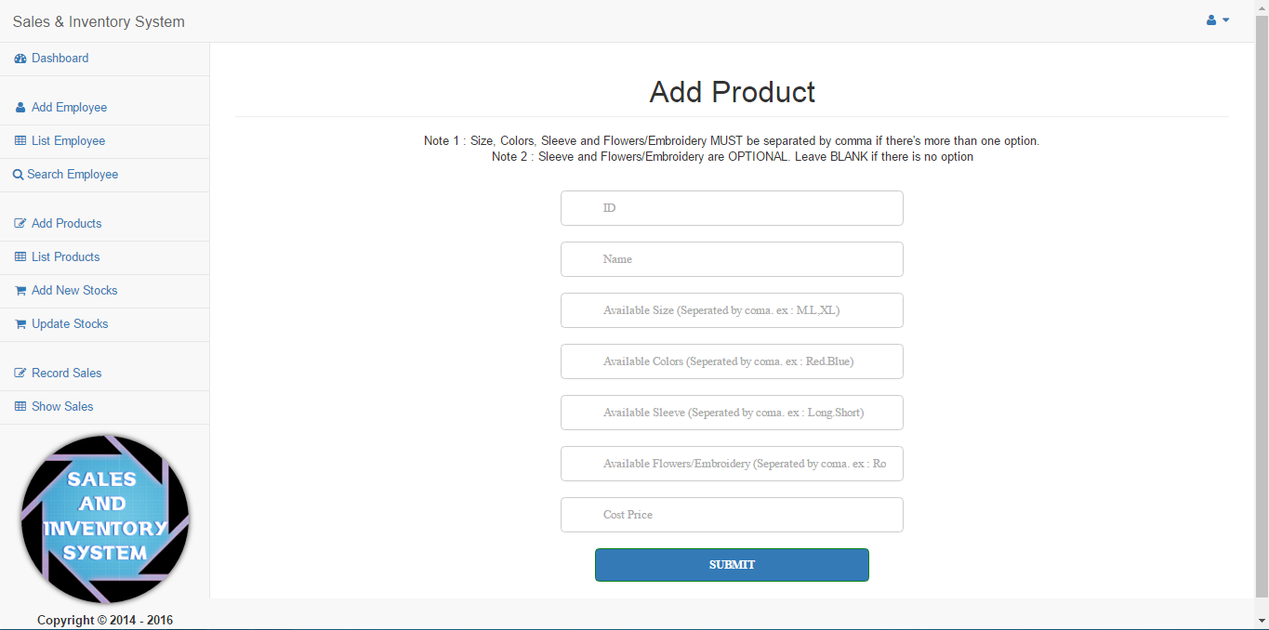

1. **List Product**

You have to click on “List Product” menu on the sidebar.



After that you will see the list of products available.

Here you can also search product by entering the Product Name in the “search product” box and hit Submit.

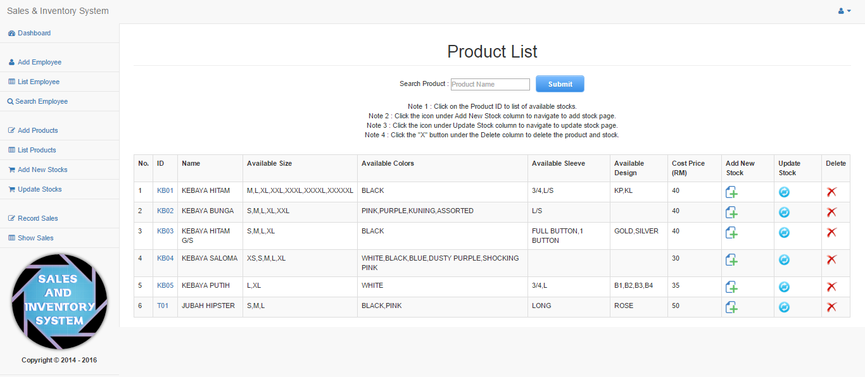

Notes :

* Click on the Product ID to list of available stocks.
* Click the icon under Add New Stock column to navigate to add stock page.
* Click the icon under Update Stock column to navigate to update stock page.
* Click the "X" icon under the Delete column to delete the product and stock.

1. **Add New Stocks**

You have to click on “Add New Stocks” menu on the sidebar.



You will see Add New Stock page.

In this page, you will see add new stock select box form, and list of currently available stocks.

You delete available stock by clickling on the “X” icon under the delete column.

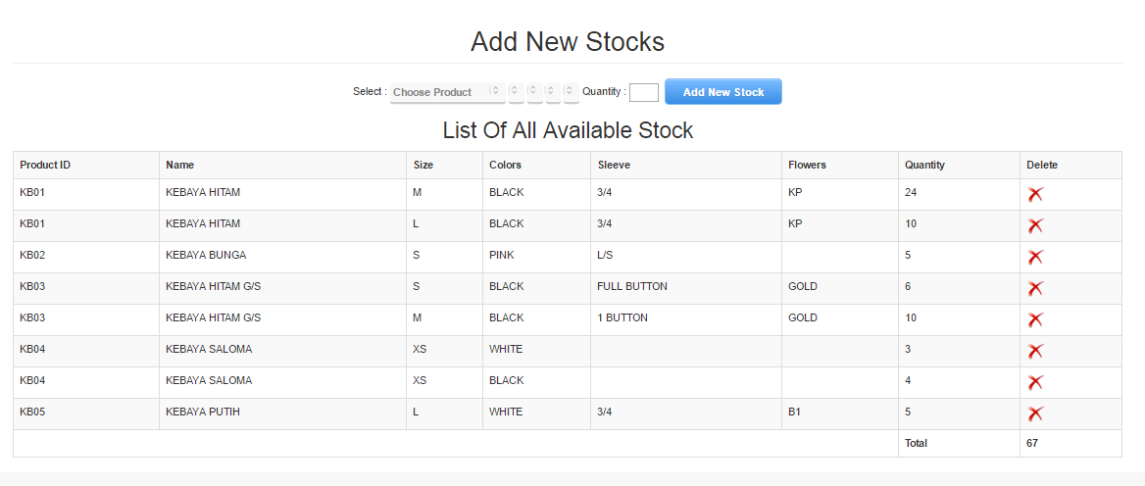

To add new stock, first, click on the “Choose Product” select box and select a Product.

After select, other select box will be updated with the product details. Choose the product details available and enter the quantity of the stocks.

Finally click “Add New Stock” to add the stock into the system.



You will see a pop up with message “Success! Data Inserted.” Indicating that the data has been successful submitted.



1. **Update Stocks**

You have to click on “Update Stocks” menu on the sidebar.



You will see Update Stocks page.

In this page, you will see update stock select box form, and list of currently available stocks.

You delete available stock by clickling on the “X” icon under the delete column.

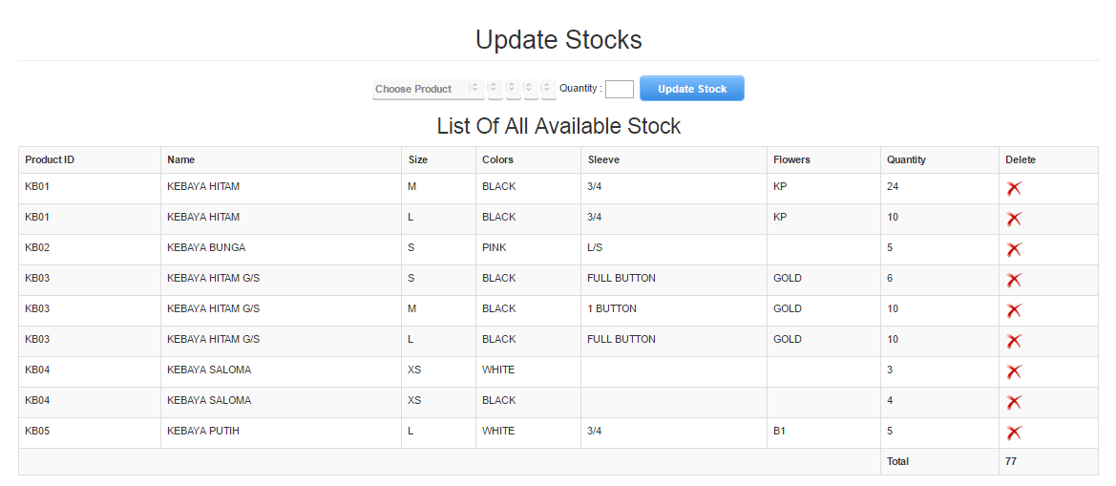

To update a stock, first, click on the “Choose Product” select box and select a Product.

After select, other select box will be updated with the product details. Choose the product details available and enter the quantity of the stocks.

Finally click “Update Stock” to update the stock.



You will see a pop up with message “Success! Stock Updated.” Indicating that the data has been successful updated.

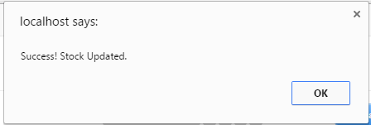

1. **Record Sales**

You have to click on “Record Sales” menu on the sidebar.



You will see Record Sales page.

To record a sales, first, click on the “Choose Product” select box and select a Product.

After select, other select box will be updated with the product details. Choose the product details available and enter the Sales Price for the product.

Finally click “Submit” to update the stock.



After successful record a sales, you will see a table containing the information of the recorded sales.

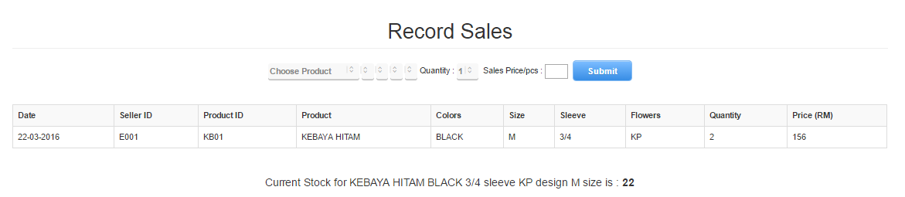

The system will also display the current available stock quantities after the sales of the product.

1. **Show Sales**

You have to click on “Show Sales” menu on the sidebar.



You will see Daily Sales button, Monthly Sales button, Yearly Sales button, from and to calendar picker box and Show button.

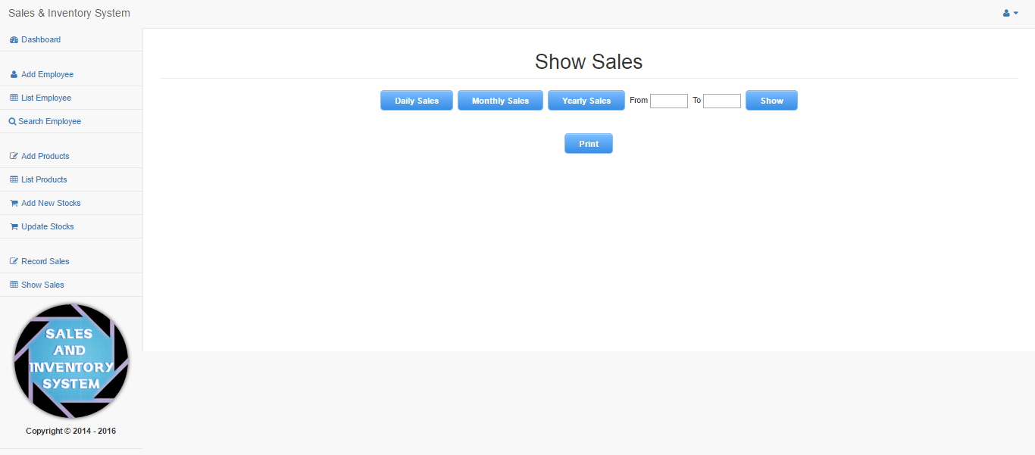

Clicking Daily Sales button will show the sales for today.

You can click Print button to print the report.

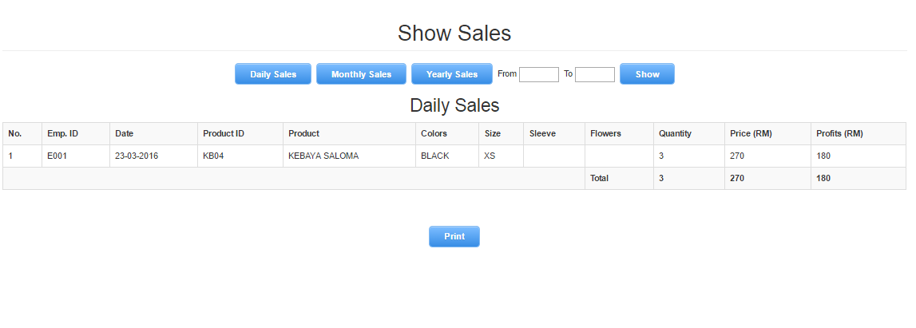

Clicking Month Sales button will show the sales for the current month.

You can click Print button to print the report.

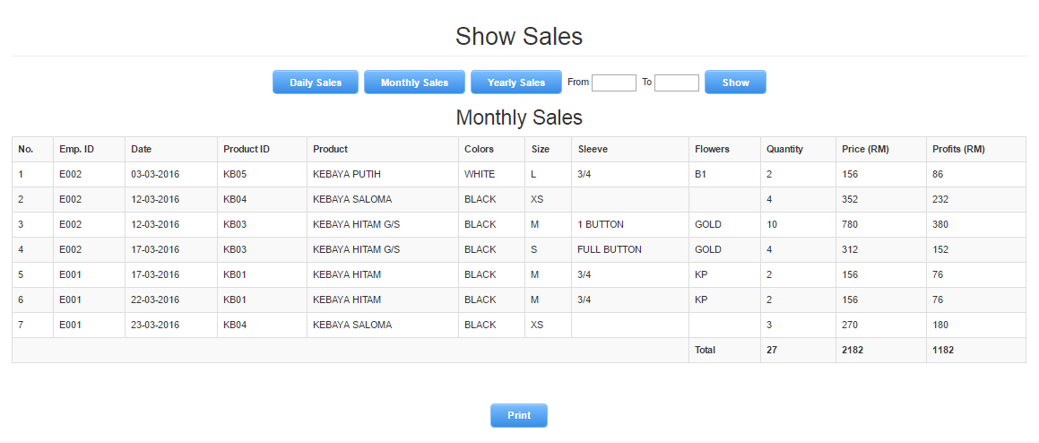

Clicking Yearly Sales button will show the sales for the current year.

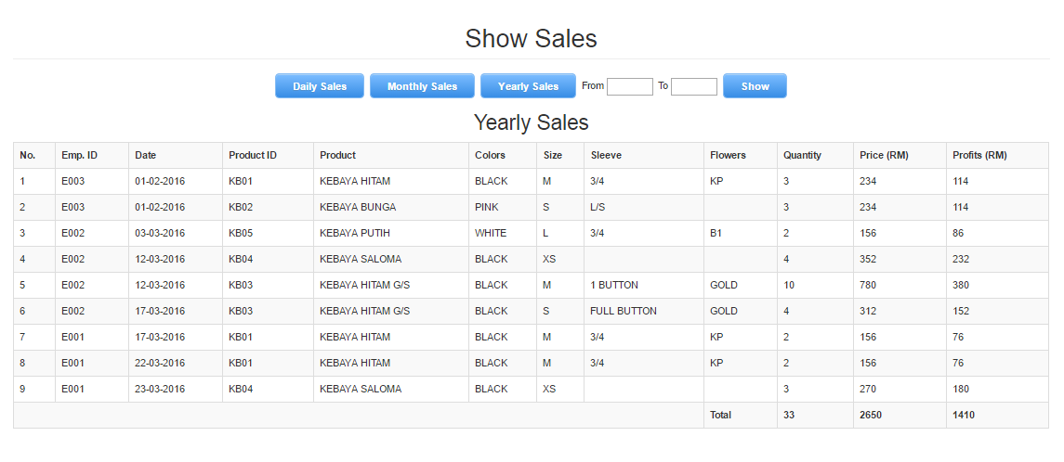

The system will also generate a bar graph based on the total quantity sold for each month.

You can click Print button to print the report.

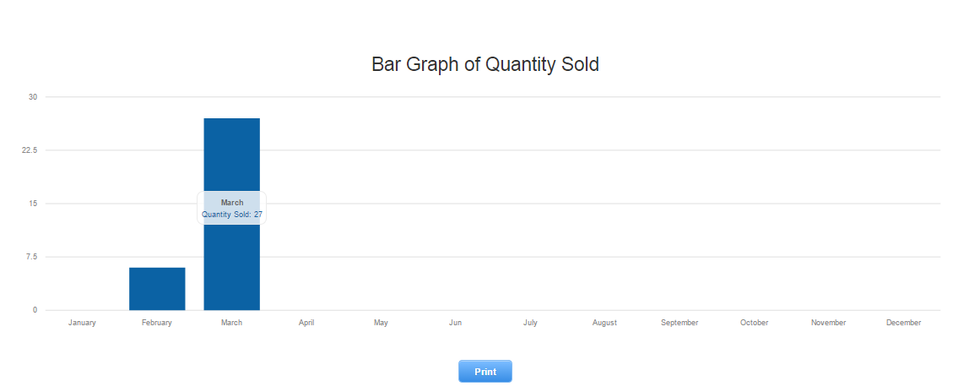

To display sales from ranges of date, first, click on “From” box and choose date from the calendar picker.

Then click on the “To” box and choose date from calendar picker.

Finally, click “Show” button to display the report.

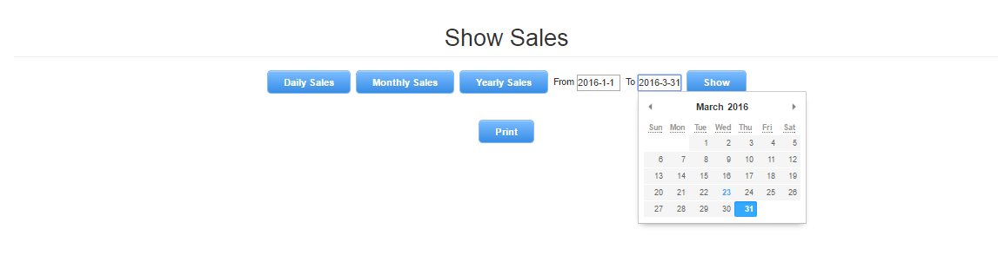

The system will generate the sales from ranges of date.

You can then print the report by clicking the “Print” button.

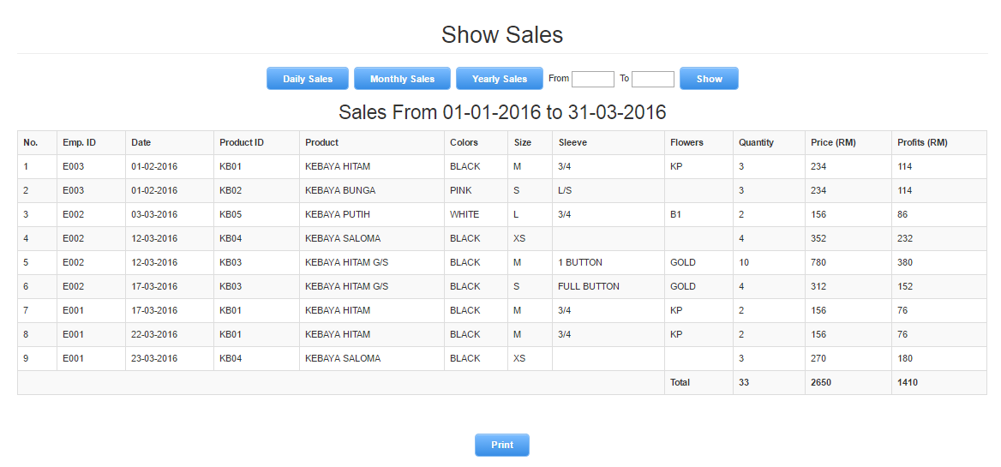

1. **Drop down menu**

Click on the icon on the upper right corner of the system to display the drop down menu.



There will be two sub-menus which are “User Profile” and “Logout”.

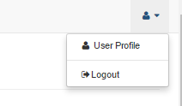

Clicking the “User Profile” menu will navigate you to view your own profile with all the details.

Clicling the “Logout” menu will log you out of the system and redirect you to the Log In page.